**LAB – 2**

Name: Gandevia Keval Dharmeshbhai

Sem: VII

Roll No: CE046

Subject: Image Processing

**Aim:** Implement basic intensity transformation functions such as image negatives, log transformations, power-law transformations, contrast stretching.

**Q. 1: Take your own grayscale photo and apply negative transformation.**

* 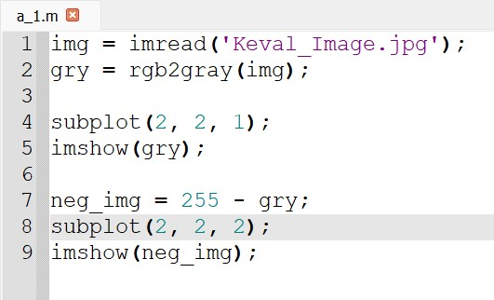**Code:**
* **Output:**

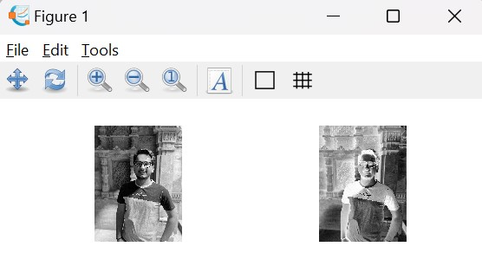

**Q. 2: Consider image ex_log.tif. Enhance the image by applying log transformation.**

* **Explanation:** After applying any transformation, if we apply mat2gray function, then we would be able to get the original image.
* 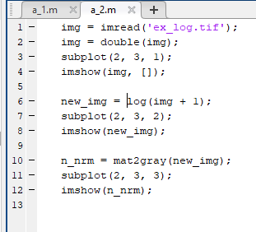**Code:**
* 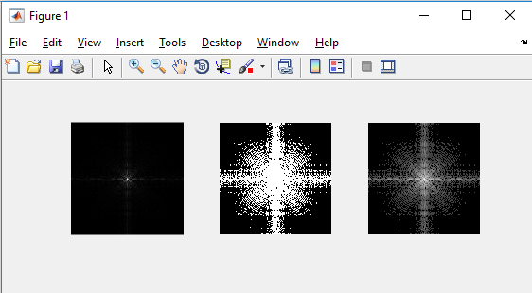**Output:**

**Q. 3: Consider images ex_power1.tif and ex_power2.tif and enhance them with power law transformation.**

* **Explanation:** During enhancing the image, if we kept gamma greater than 1 then it will brighten the image and if we kept gamma less than 1 then it will lighten the image.
* 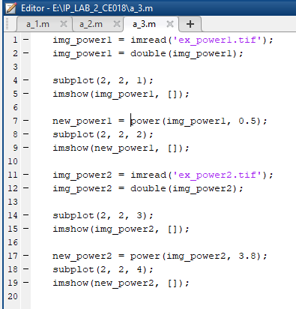**Code:**
* 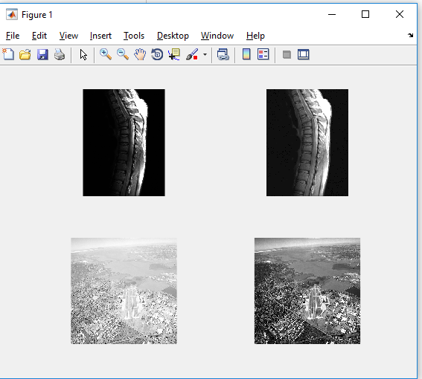**Output:**

**Q. 4: Consider your over exposed photo and enhance it by power law transformation. Specify the value of gamma which is suitable for this enhancement.**

* **Explanation:** Over exposed image means there is too much light in it. Therefore, we need to enhance that image to get back original image. For that we can use power law transformation with the gamma value greater than 1 as it brightens the image.
* **Code:**

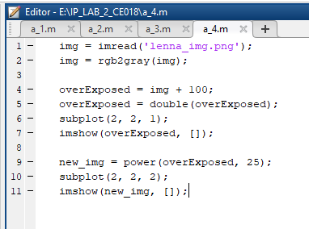

* **Output:**

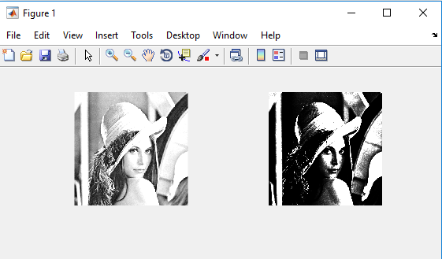

**Q. 5: Consider your over exposed photo and enhance it by power law transformation. Specify the value of gamma which is suitable for this enhancement.**

* **Explanation:** Under exposed image means there is not enough light in it. Therefore, we need to enhance that image to get back original image. For that we can use power law transformation with the gamma value less than 1 as it lightens the image.
* 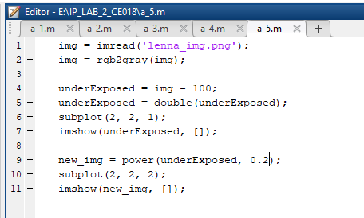**Code:**
* **Output:**

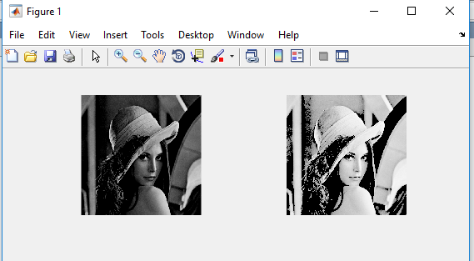

**Q. 6: Contrast stretching example: A 3 X 3 bits/pixel image is given by [7 12 8, 16 9 6, 10 15 1]. Apply contrast stretch to the image so that the new image has a dynamic range of [0, 255]. Also show the output image. Sketch the transformation you used for contrast stretching.**

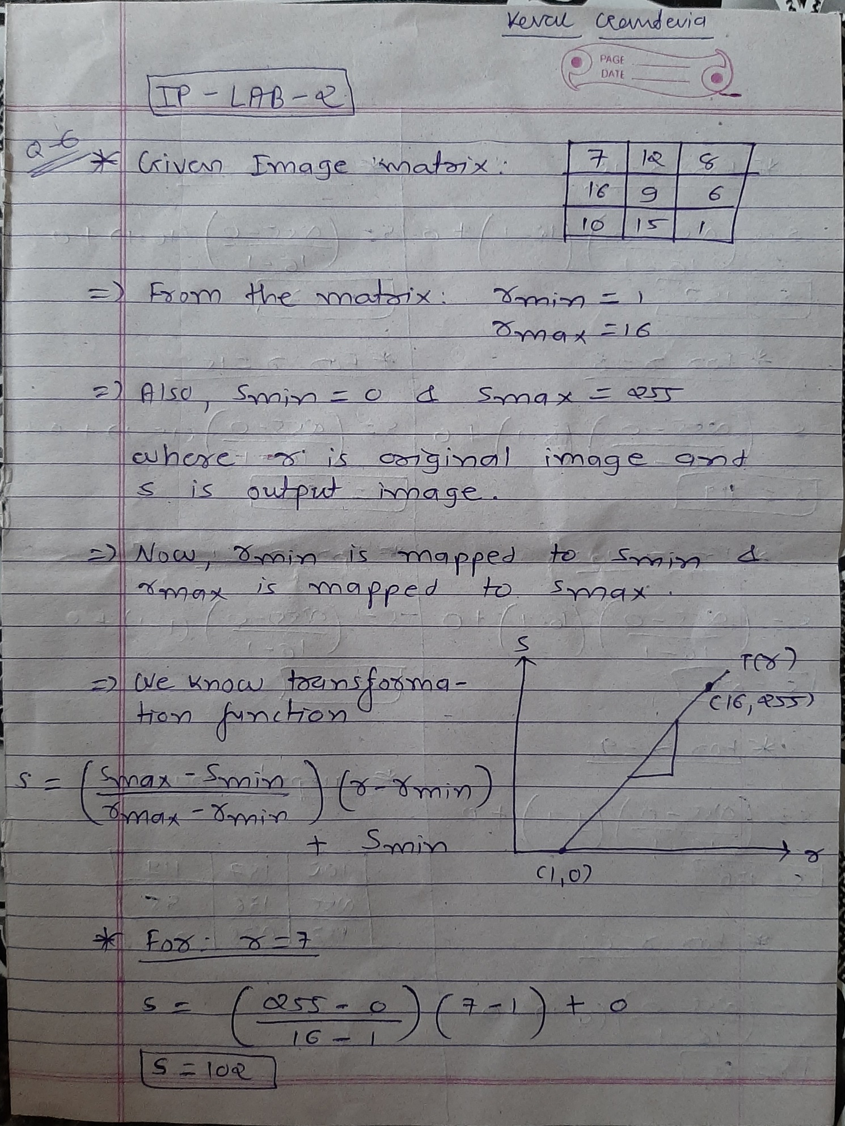

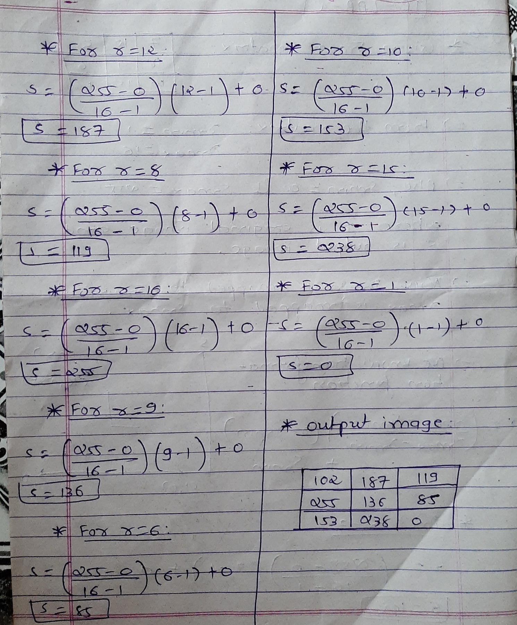

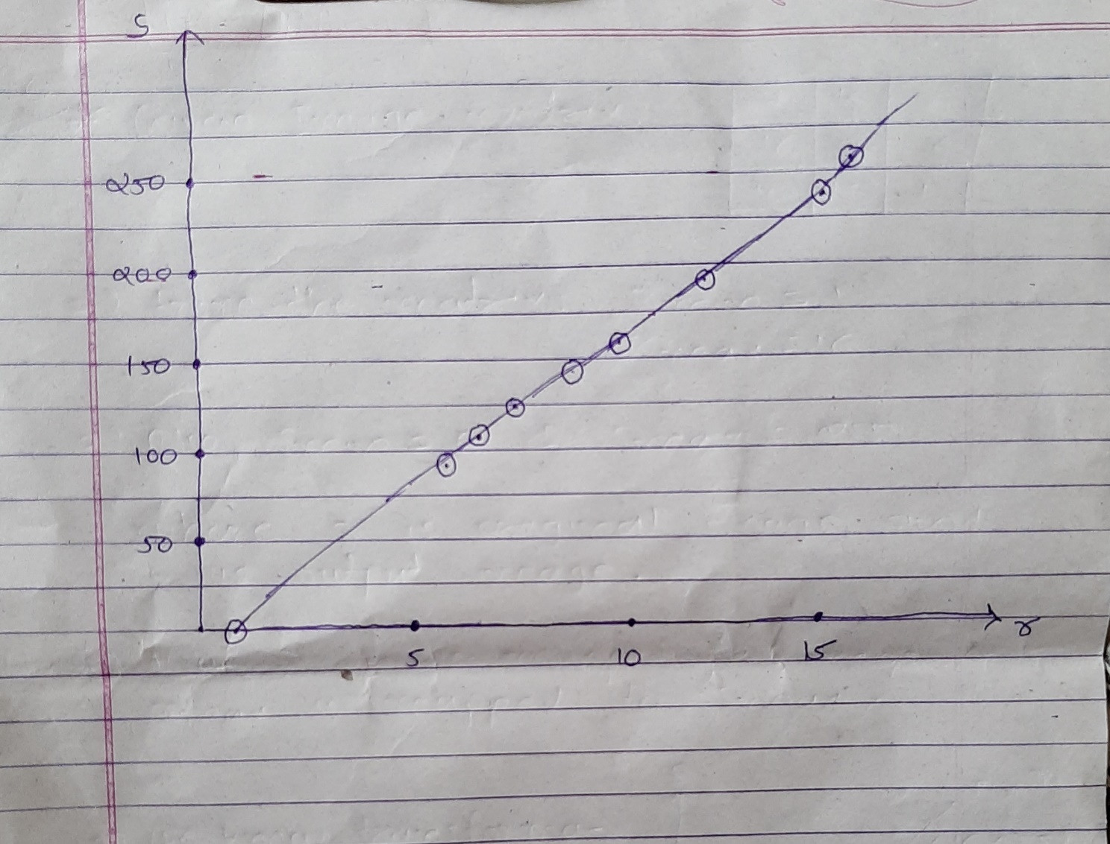

**Q. 7: Do contrast stretching for the image ex_contrast.tif. Obtain contrast stretched image from low contrast image and apply thresholding.**

* 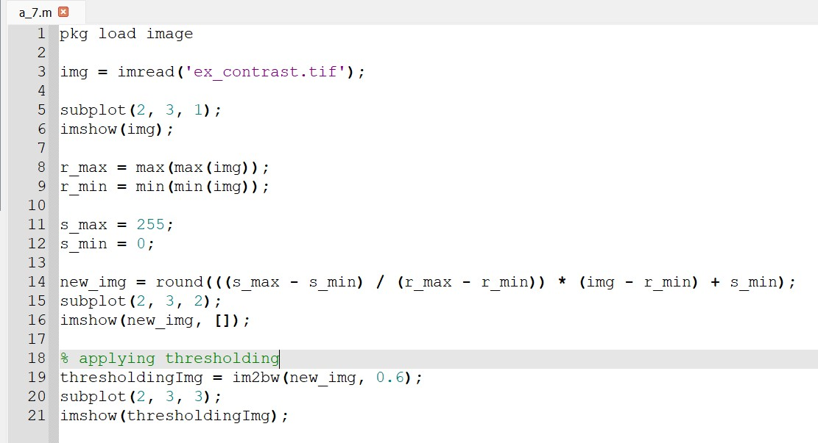**Code:**
* 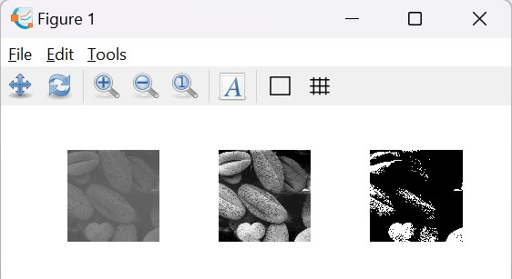**Output:**

**Q.8: Take any photo of yours:**

1. **Convert it into gray scale.**

* 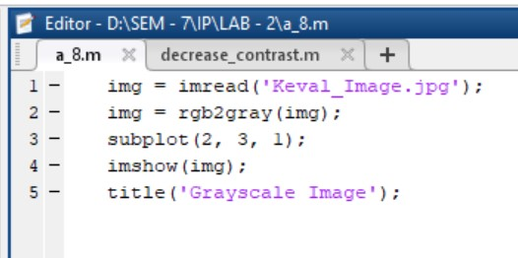**Code:**
* 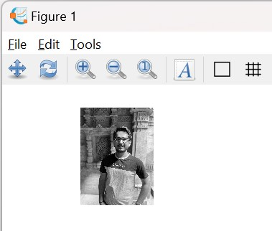**Output:**

1. **Create a function that would decrease the contrast of this image.**

* 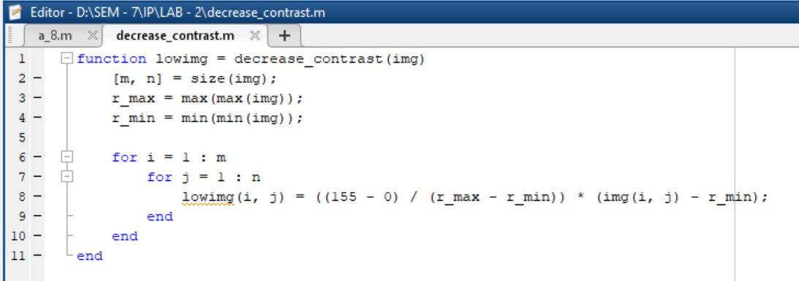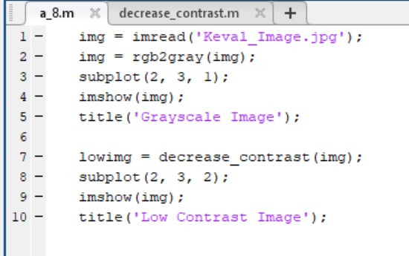**Code:**
* **Output:**

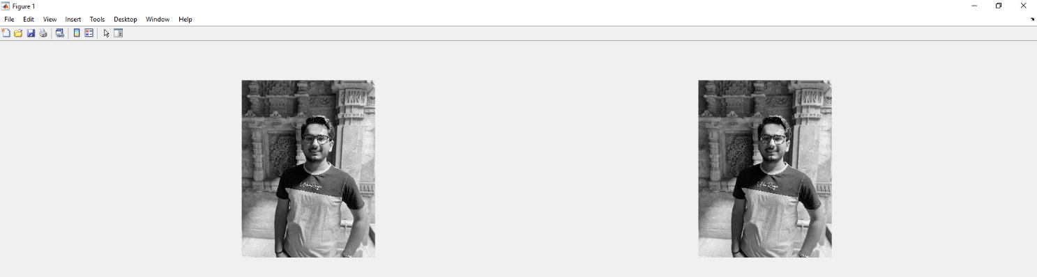

1. **Enhance the contrast of that image using piecewise linear operation for contrast stretching.**

* **Code:**

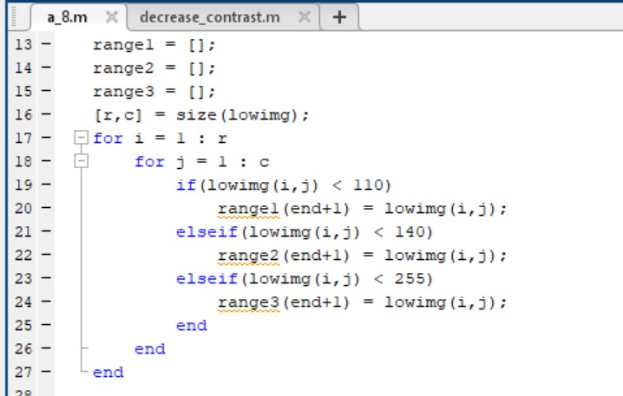

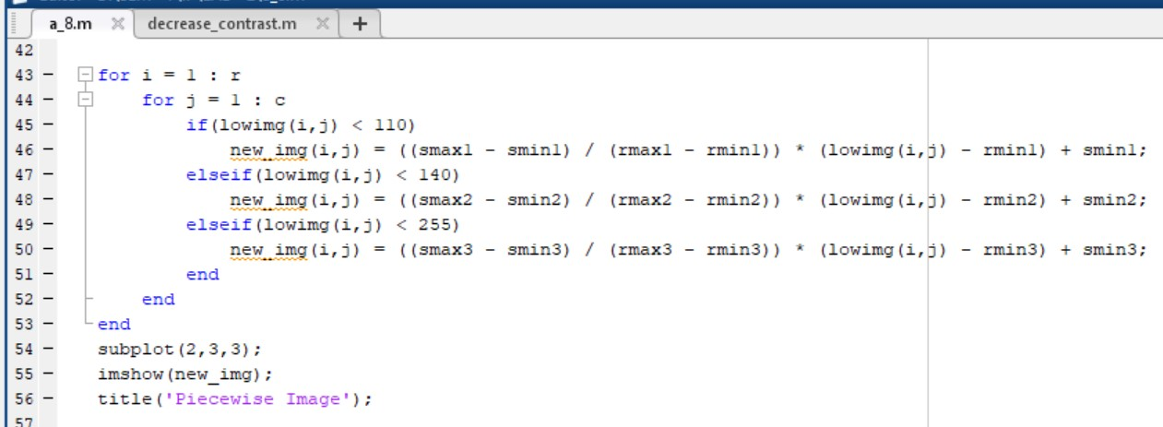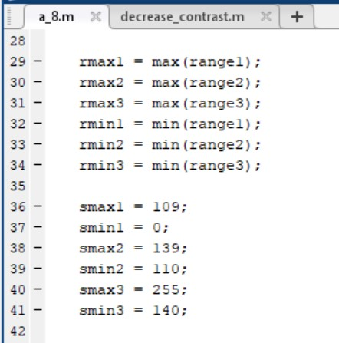

* 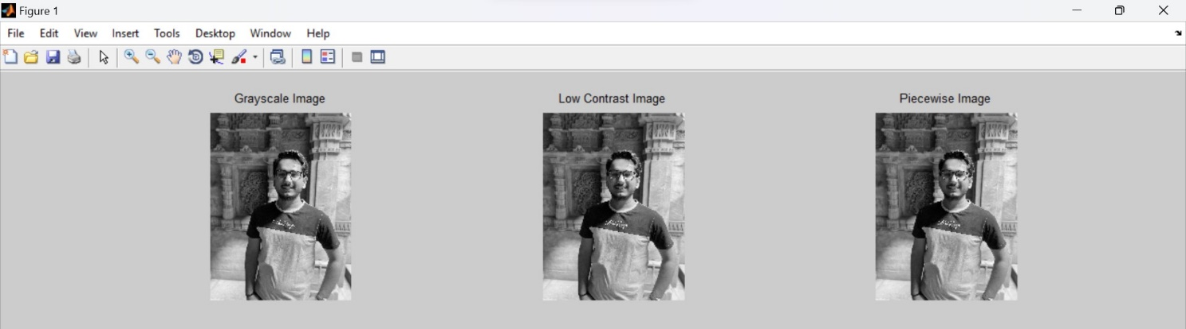**Output:**